**Restaurant Management System**

**Vineeth Adithya Dodla**

**9/28/2017**

**Restaurant Management System:**

The proposal is to create an online reservation system for a restaurant, besides providing other features like employee portal, and a job portal for the particular restaurant..

**Scope and objective:**

This project will focus on online reservation system, employee portal and creating a job portal where individuals can look for the open job positions and drop an application for the position they are interested in. It also features a rating where customers are encouraged to post their views on the restaurant so that the restaurant can improve its functioning based on the ratings.

**Project Environment:**

We are developing a web based application for a restaurant. Using HTML as our primary source for developing the web page and link the data base MySQL using php interface .

**Intended users of the website:**

This webiste can be used by any customer to make a reservation at the restaurant. This website helps the user(manager) to make changes to the menu and update the reservation of a customer and it can also be used by individuals who are seeking employment in the food industry.

**Content of the website**:

This website has 6 html pages which provide different funcitonalities. The webpages are named as home, menu,reservations,about us,employee login, job application. The content of each page is explained in the Html section.

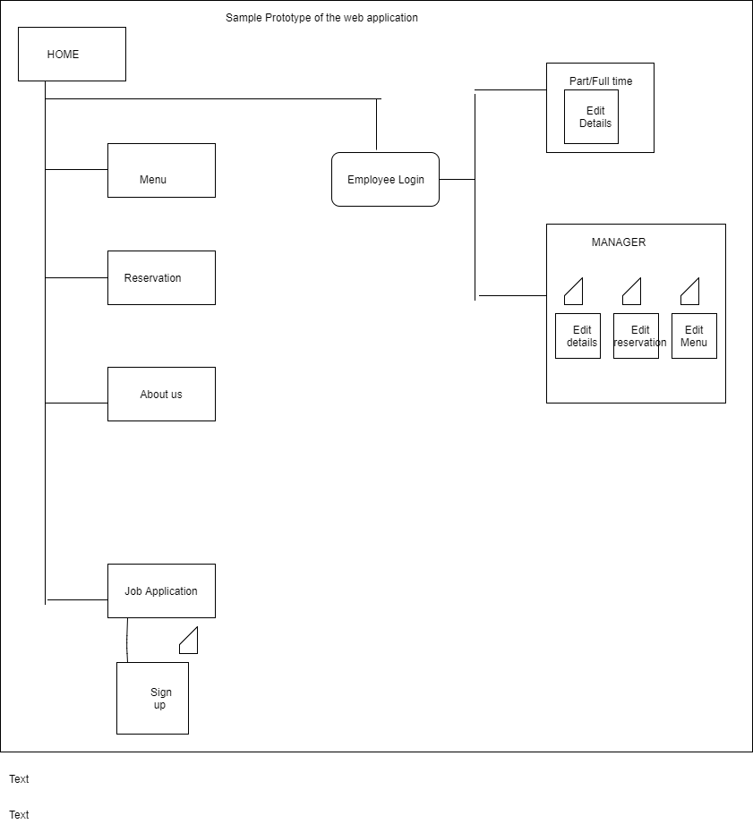

**Prototype of the web application**

**HTML Pages**

**About Page:**

*Purpose:*This page gives information related to the restaurant details viz address and the branch locations. Like when the restaurant was established and who started it and any special listings that the restaurant may have(honors or achievements).

*Audience:*Open to all the public.

**Home page:**

*Purpose:* This html page is the main page of the web application. We can navigate to other html pages from this main page. It has information related to the working works displayed and the contact details of the restaurant which allows the customers to approach the management easily.

*Audience*:Open to all public.

*Datafields*: All the information related to the restaurant be in text.

**Menu page:**

*Purpose*: The purpose of the menu page is to give details with respect to the available food items at the restaurant for dining and take away. All the details will be arranged in section wise pattern so that the customer finds it easy to look and order his dishes.

*Audience*: Open to all public.

*Datafields:* Information related to the menu of the restaurant organized into different sections.

**Reservation page:**

*Purpose*: This page allows the user book or make reservations for dinner,lunch,brunch,breakfast. With respect to the business logic this page offers a provision to edit or delete a previous reservation made when logged in as an employee into the application.

*Audience*:Open to all public

*Datafields*: Will have fields like type(a basic dropdown with fields breakfast,dinner,lunch,brunch), name of the guest, number of guests accompanying and a submit button.

* Upon filling the details and clicking the submit button the data of the guest will be stored in the database with a unique guest id.
* When logged in to the application as an employee you have a provision to change the reservation made by the customer.

*Validation*: All the data fields in the page should be filled.

**Employee Login page:**

*Purpose*: This page is exclusively designed for the employees and the future employees of the restaurant to access to their details and functionalities. For the current employees it helps to access their information(personal) and gives a privilege to update the personal information.

* Employees are classified into three different sections(full time employee,part time employee, manager level). Manager level employees are given full access and provided with additional functionalities like making changes with the reservation and menu.

*Audience*: Open to all public

*Datafields*: ID

Passkey

Type of employee(radio buttons for type)

Submit (radio button)

* If the type of employee is partime or fulltime after the submit button is clicked they are navigated to a new page with links to access their personal information.
* Upon clicking personal information you can see the details and can edit the details.
* If the type of employee is manager, he/she are navigated to a new page with links to access their personal information, edit the reservation, edit the menu.
* As a manager you can edit the reservation by clicking on the edit reservation link and typing their unique guest id.
* As a manager you can edit the menu by clicking on the edit menu link and with the help of the name of the dish.
* Any changes made with respect to the personal details or menu or reservations will be reflected in the database.

*Validation*: All the data fields should be filled.

**Job Application Page:**

Purpose: This page serves as a platform to seek attention of the future employees they can give their details and create an account by filling a form.

Audience: open to public (intended for future employees)

Datafields: personal details of the future employee viz..

Full name:

Date of birth:

Educational details:

Experience:

Contact details:

Skills/achievements:

* user will be directed a page with a link to fill an employee application form. The employee application form contains data fields pertaining to the personal details of the user.